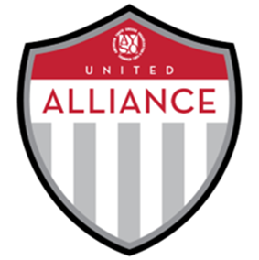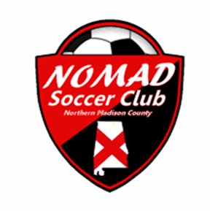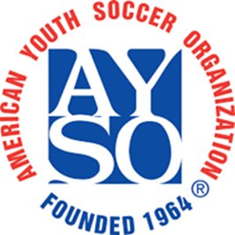

AYSO Region 1174 and AYSO North Alabama Alliance FC
Our AYSO Region NEEDS YOUR SUPPORT!
Dear AYSO Sponsor:
AYSO is the largest youth sports program in North Alabama with programs in Madison, Huntsville, New Market/Hazel Green, East Limestone, Monrovia, and Killen. The registration fee paid by each player covers only a portion of the total expense.
Your gift directly supports this quality, extra-curricular program for our youth.
For your tax deductible donation, you will receive benefits that correspond with the attached donor letter. For Club and Area donations we would love to talk to you directly to see how we can partner together to maximize your donation.
But, most importantly, you’ll receive the gratitude and recognition from over 3,000 local families who are doing what we can to make sure EVERYONE PLAYS and has an enjoyable soccer experience.
All contributions are tax deductible² and the full amount of your sponsorship directly supports our AYSO Region, an all-volunteer organization. If you require more information, please contact the Regional Commissioner or Area Director.
Thank You

AYSO is a non-profit corporation (tax ID #95-6205398; Section 501 (c) (3) of the Internal Revenue Code)

Sponsorship Level: Player ($100-$400) Team ($401-$1000)
Club ($1001-$5000) Area ($5001+)
Sponsorship Amount: ______________________________________________________________________
Sponsor Name:
Player/Volunteer Supporting: _________________________________________________________________
Website:
Mailing Address:
City, State, Zip:
Contact Name: Telephone:
Email:
Please make your check payable to AYSO Region 1174. Mail return this form with donation via the player/volunteer who you are working with:

